**Task 1**

<https://www.linkedin.com/in/christopher-bibby-940722124/>

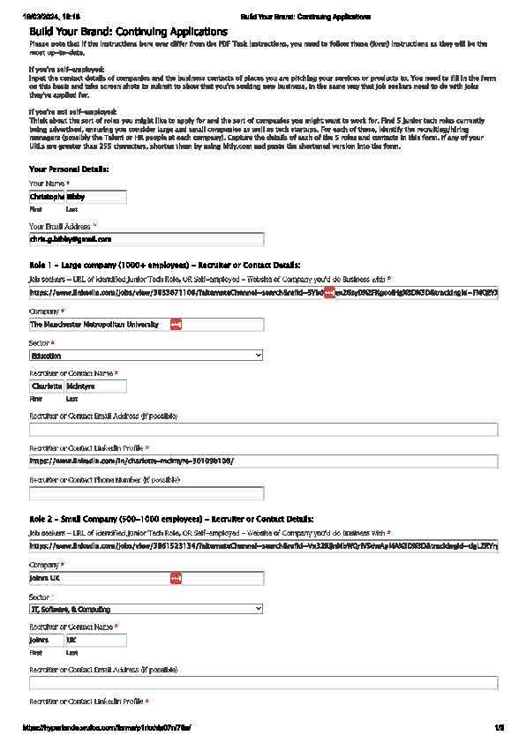

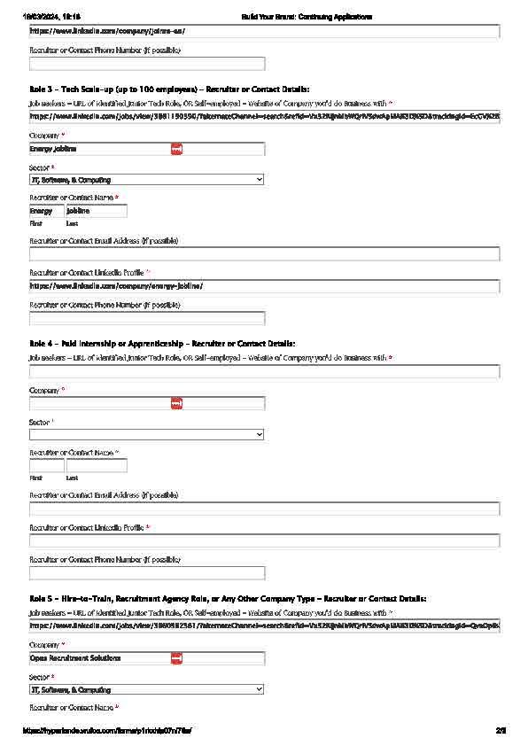

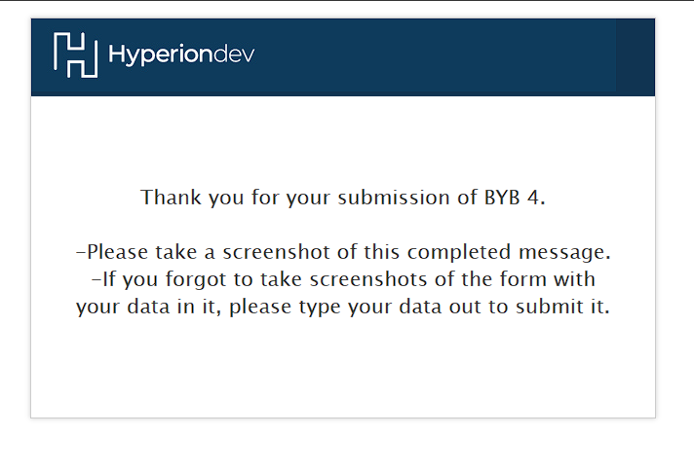

**Task 2**

Job description:

The Data Analyst role is based in the Sustainability Team in the EFCD Directorate and will primarily support the Sustainability and Space Management teams, but also other EFCD departments as required in developing an approach and streamlining data management processes, analysing, and interpreting complex data, and presenting the findings to a range of audiences.

The responsibilities of the Data Analyst will include but are not limited to:

* Providing technical expertise and support to non-experts across the EFCD Directorate
* Developing reports and presentations with recommendations to a variety of stakeholders
* Development, analysis, and maintenance of datasets
* Provide guidance and advice on data quality issues
* Responsible for visibility, accuracy, and transparency of data sets

Company description:

Manchester Metropolitan University (MMU) is a renowned institution in the United Kingdom, known for its excellence in higher education and research. Located in the vibrant city of Manchester, it offers a diverse range of undergraduate, postgraduate, and research programs across various disciplines, including arts, humanities, sciences, business, and education. MMU prides itself on its commitment to innovation, inclusivity, and community engagement.

As someone who thrives in dynamic environments and values collaboration, I would be a great fit for MMU. My track record of contributing positively to teams and my passion for education, from my time volunteering at a local primary school, align well with MMU's values. I firmly believe I can be an asset to the university's mission of fostering academic excellence and driving positive change.

Working at MMU would provide me with the opportunity to be part of a forward-thinking institution dedicated to empowering students and making a meaningful impact on society.

My Background:

This Data Analyst role offers a dynamic opportunity within the Sustainability Team of the EFCD Directorate, focusing on streamlining data processes and analysis to support various departments. The appeal lies in the chance to provide technical support, develop insightful reports, and contribute to data-driven decision-making. Responsibilities include maintaining datasets, ensuring data quality, and enhancing data transparency. The role not only involves technical expertise but also communication skills, as findings need to be effectively presented to diverse stakeholders. The opportunity to work across departments adds to the role's appeal, promising a diverse and impactful work environment. Overall, this position aligns with my interest in leveraging data to drive sustainability initiatives while providing opportunities for growth and collaboration across teams.

Mistake and learning:

Situation**:** While organizing a team event, I delegated tasks without clear instructions, assuming everyone understood their roles.

Task**:** My task was to ensure the event ran smoothly by assigning responsibilities effectively.

Action**:** During the event, tasks were not completed as expected, leading to confusion and delays. I realized my assumptions of understanding was a mistake. Instead of blaming others, I took ownership of the situation. Then I immediately stepped in to clarify roles and assist where needed, salvaging the event's success.

Result**:** The event ended decently, but the hiccup left an impact. I reflected on the importance of clear communication and proactive follow-up.

Lesson Learned**:** From this experience, I learned the significance of explicit communication and confirming understanding. I recognized the need for periodic check-ins to ensure tasks are on track, preventing misunderstandings and improving team efficiency.